Lets upgrade linux

Assignment-2

Task:Add a 10gb disk to cent os

Verify by using fdisk -l

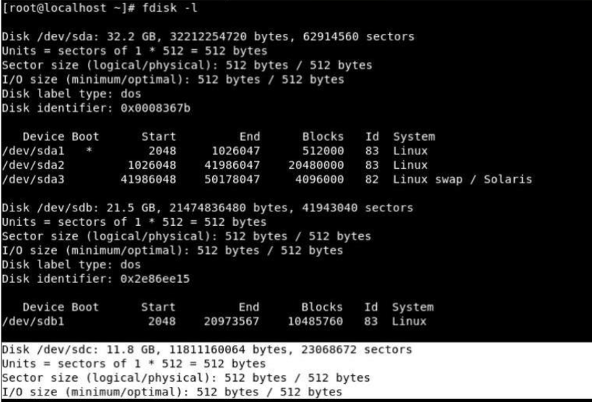

Task :Create two partitions of 4gb and 6gb

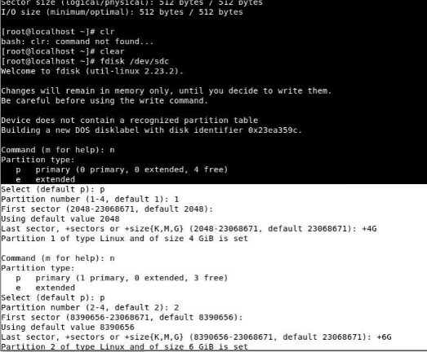

Task: Format 4GB with xfs and 6GB with ext4 file system.

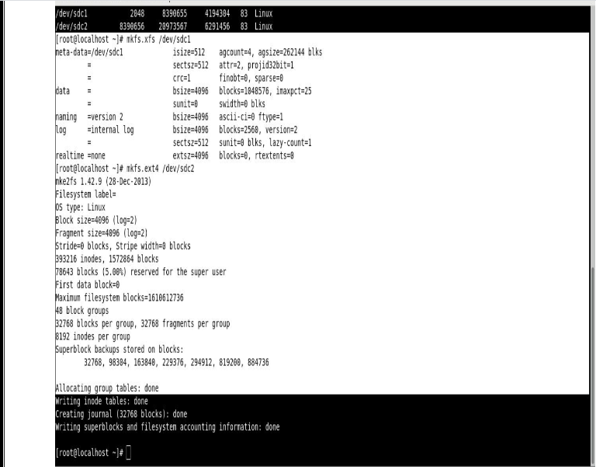

Task: 4. Mount 4GB and 6GB in /data and /music directory respectively.

Creating mount point using fstab file

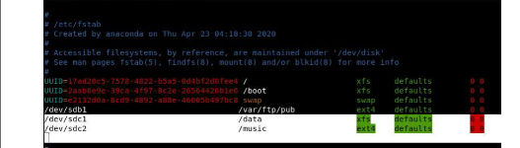

Verifying whether mount point is created

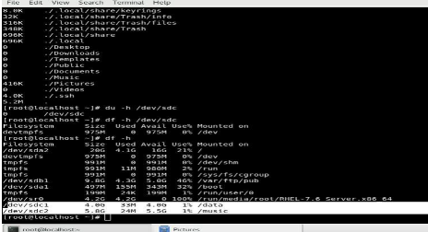

5. Create one file of 1GB in each of the mount point created above.

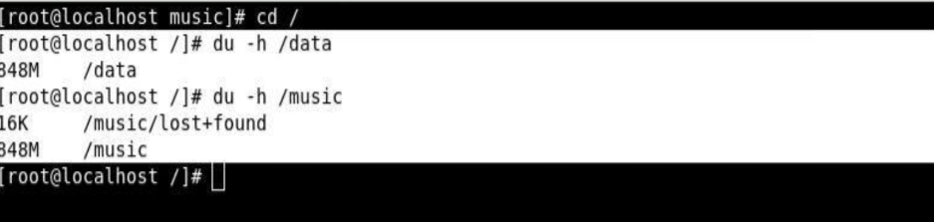

Creating 1gb file using seq>1000000 command

Here the file created is having 848mb which is closest to 1gb

6. Verify the disk Consumption and disk space free in the mounted partitions.

Verify disk usage using df -h command

